Motor Sizing Software

Admin Manual: PBA System

Version 4

Topra World Pte Ltd

8 Eu Tong Sen Street

#14-94

The Central

Singapore 059818

**IMIT (Pvt) Ltd**

**No 82, Galle Road , Colombo 04, Sri Lanka**

**Phone: (+94)719927926 Fax: (+94)115926926**

**Web :www.imit.lk Contact: info@imit.lk**

Contents

Motor Sizing Software 1

A User Manual: PBA System 1

Revision History 3

Purpose 4

Masters 4

Common Component 4

Master Data grid 4

Detail Section 4

Search (Optional) and Data Manipulation. 5

Motor Category 5

Usage of Fields 6

Motor Master 7

Usage of Fields 7

Servo Drive Master 8

Usage of Fields 8

User Master 9

Usage of Fields 9

Special Users 9

Admin Tasks 10

User function 10

Login 10

Version Generation 11

Revision History

|  |  |  |
| --- | --- | --- |
| **Name** | **Date** | **Remarks** |
| Lakmal | 07th April 2021 | Initial Document |

Purpose

Purpose of this document is to explain the master data behavior of the PBA system and how those relate to motorsizer fuctions.

# Masters

In this section will exapllain use of fields from the master. This will not include the business related paraeters. However, this will explain the fields that has an impact on motor sizer fuctntionality. Pleas note that masters can be accessed only by the application registered users only. Other users will be considered as Guest users and will have access only to motor sizer.

## Common Component

Below is the setup for every master which shares the uniform design.

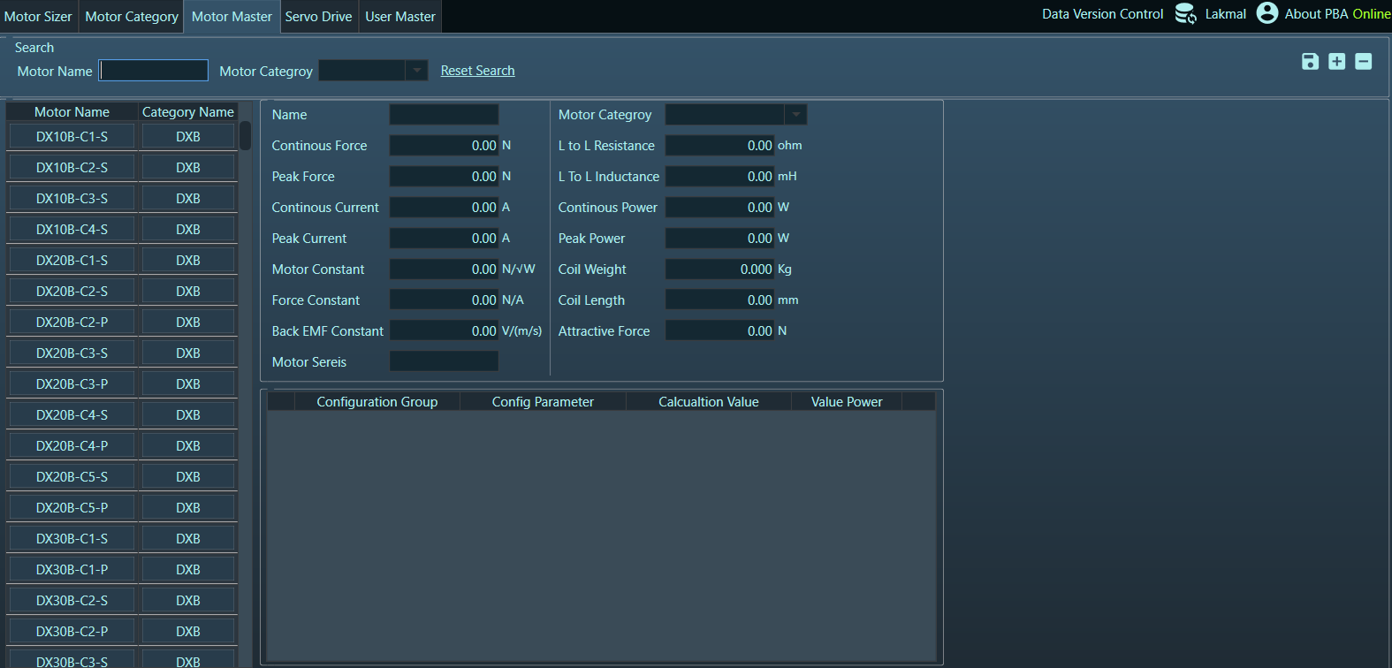

1

3

2

1. Master Data Grid
2. Detail Section
3. Search (Optional) and Data Manipulation.

### Master Data grid

Master data grid fetch all the records from the relevant master data and when one record selected then relevant master details will be loaded to the Detail section.

### Detail Section

Deatail section loads the selected master and allows the user to edit the data.

### Search (Optional) and Data Manipulation.

Search section can be used to filter the master data grid using given parameters. Search function doesn’t include in all the masters. Masters with limited number of records do not equipped with this features.



#### Save

Delete

Add

Save

Save button affect the changes to the database done in

the detail section.

If it’s a new record then it will insert the record to the database else it will update the existing record.

#### Add

Add new record to the master

#### Delete

Delete the master record in the detail section.

## Motor Category

Motor Category master holds the motor categrories.

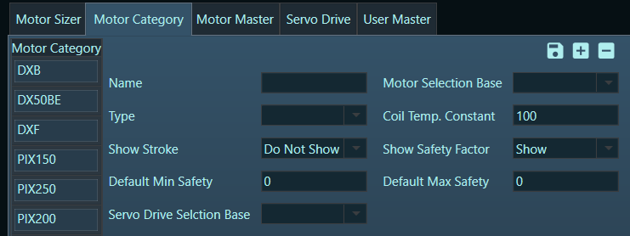

### Usage of Fields

| Field Name | Impact on Motor Sizer |
| --- | --- |
| Motor Selection Base | Current – Consider the required current and mortor current to retrieve the recommended motors  Force - Consider the require force and mortor force to retrieve the recommended motors |
| Type | This defines whether motors under this category are Rotory or Linear |
| Coil Temp Constant | Maximum coil temperature specification (℃) (). Use to calculate the coil temperature. |
| Show Stroke | This will decide whether to display Stroke under selected motore section. The display fields as below based on the value  Show Stroke   * Coil Length and Attractive forces will be hidden * Strok will be visible   Do not Show Stroke   * Coil Length and Attractive forces will be visible * Strok will be Hidden |
| Show Safety Factor | Decide to whether to show the General Saferty factor or other Safety factors in the Calculated Motor Values for application section  Show Safety Factor   * Below fields will be hidden   + Safety Factor Current   + Loading Factor Current   + Safety Factor Force   + Loading Factor Force * Safert Factor will be visible   Do not Show Safety Factor   * Safert Factor will be Hidden * Below fields will be Vissible   + Safety Factor Current   + Loading Factor Current   + Safety Factor Force   + Loading Factor Force |
| Default Min Safety  &  Default Max Safety | Provides the Default values for Safety Margin |
| Servo Drive Selection Base | This values will decide the type of servo drive to be considers in motor sizer selection. Same field appear in the Servo driver master as well. |

## Motor Master

Motor master holds the motor Master under each motor category.

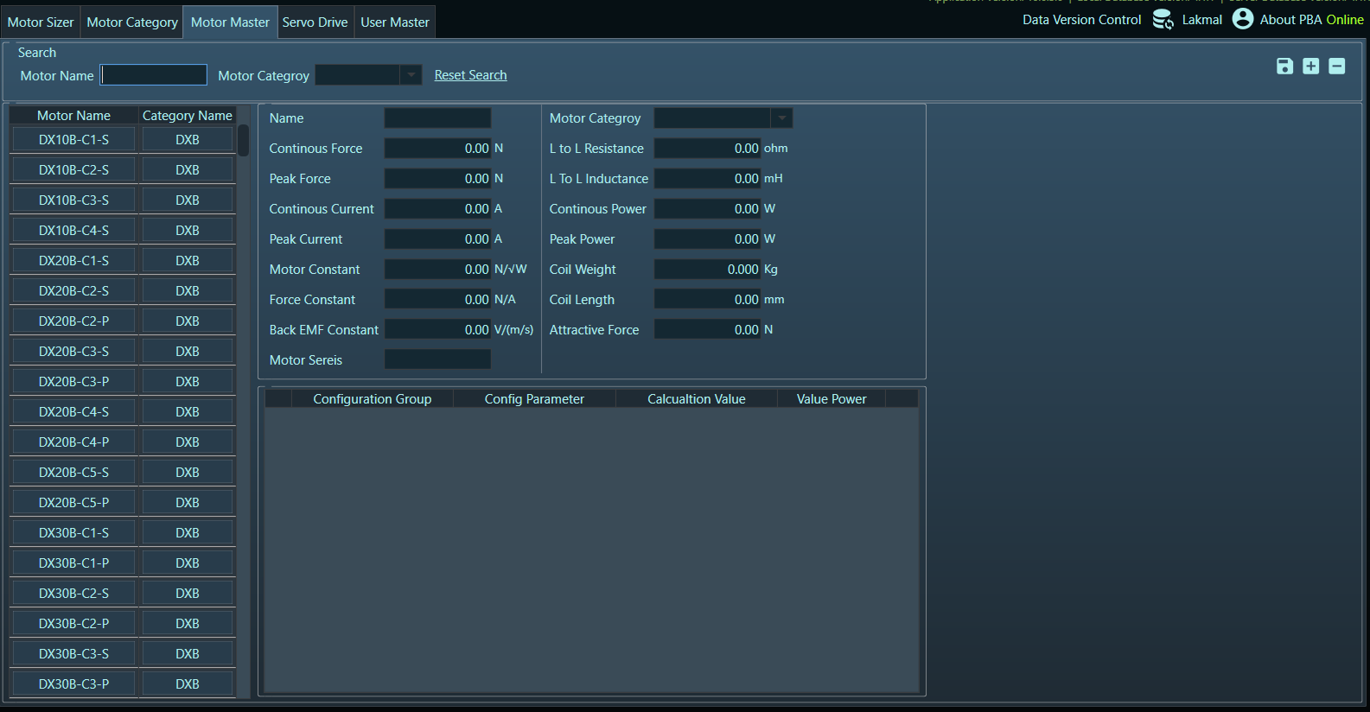

### Usage of Fields

| Field/Section Name | Impact on Motor Sizer |
| --- | --- |
| Motor Series | Motor series is a grouping of a motor within Motor category. This reflects during recomanded motor selection, which list maximum two records per motor series. |
| Motor Parameters | Motor prapmeters are special parameters that can be used for Motor specific reasons. User cannot add new paramers through the application. However user can edit the Configuration values (Numeric ) and Valuyes power can use to set the big number. Currently we use this for PIX250 & PIX150 motors  Ex: if required config value is 3x10⁸ then value can be set as below   |  |  | | --- | --- | | **Config Value** | **Value Power** | | **3** | **8** | |

## Servo Drive Master

Servo Drive holds the Servo Drives.

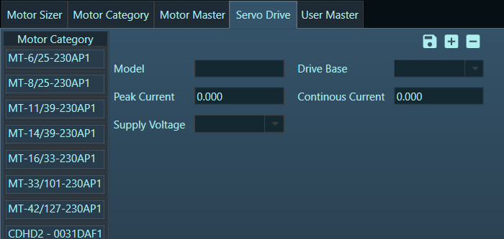

### Usage of Fields

| Field/Section Name | Impact on Motor Sizer |
| --- | --- |
| Drive Base | Drive Base use to recgnise the relevant Servo drive based on the selected motor category. Motor Categroy Servo Drive Selection Base and Drive Base of the servo drive should be same to be considered for relevant servo drive selection. |

## User Master

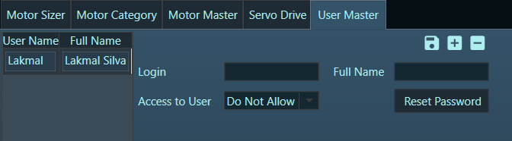

### Usage of Fields

| Field/Section Name | Impact on application |
| --- | --- |
| Access to user | If this access allows then relevant user has the rights to access the user master and perform the besic system admintration tasks including resetting the password. |
| Reset Password | It’s mandotorary to reset password for a new user    Password requirrment   * Should be greater than eight charcaters * Should include atleast one uppercase letter * Should include atleast one lowercase letter * Should include atleast one number * Should include atleast one special character (!,@,#...) |

### Special Users

Application has two special user that cannot be created. These are system users with specific roles.

**Guest user –** Guest user is the default user for the application. It doesn’t need login and has accces only you motor sizer application

**SystemAdmin user –** System admin is a special user which has accces only to user master. Password oif the user will be maitained out side the application.

# Admin Tasks

## User function

### Login

User can click on the 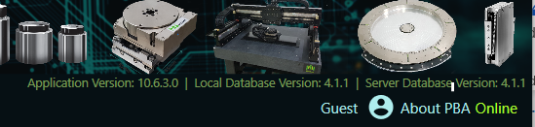 icon to pop login button to login for the master data access.

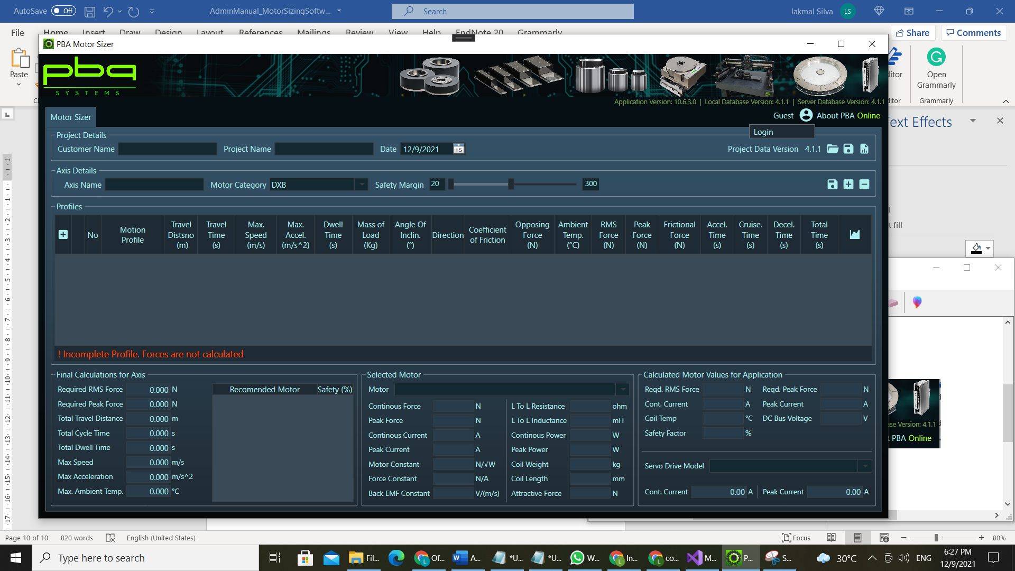

Once user clicked the login button application will popup the login screen which open the access to the masters.

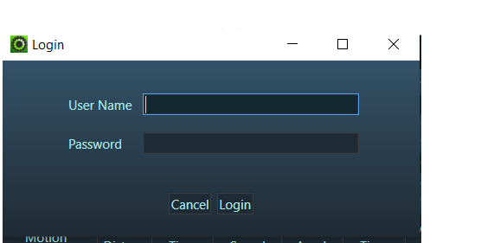

Once user loign user will have the two functions with same user  icon

**Logout** - Can logour from the master access

**Reset Password**  - Can reset the logged in users password.

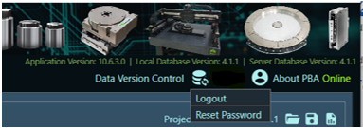

## Version Generation

Version generation is processe of master data entry confirmation. Please note at the point of master data insert or update will not reflect them for the motor sizing process. User will have to generate the master data version. User can decide based on amount of the change which type of version will be generated.

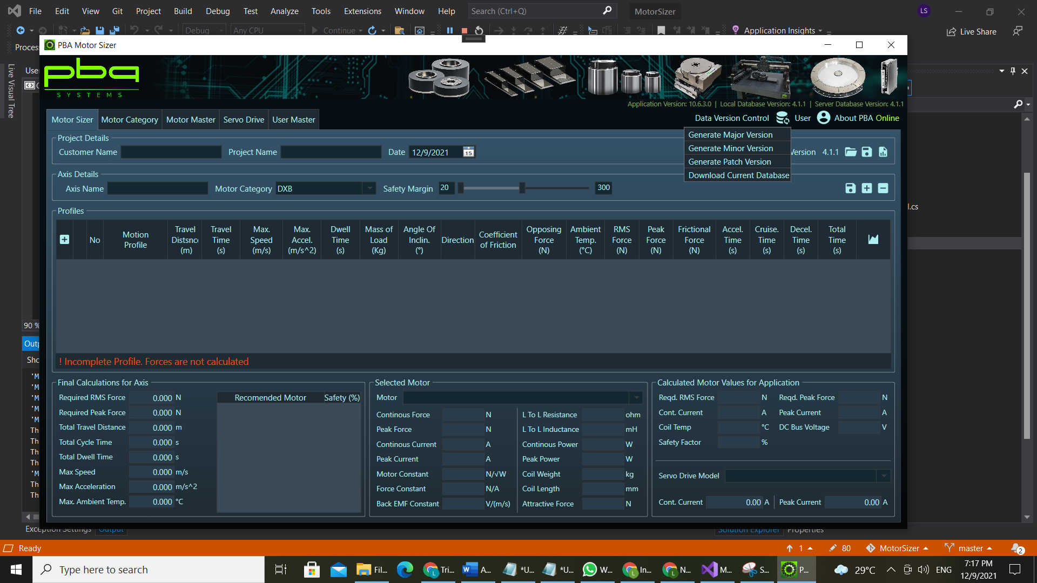

**Generate Major Version** – If the change is significant then user can generate Major version

**Generate Minor Version** – If the change is minor then user can generate Minot version

**Generate Patch version** – This is to generate a version with a small change or a fix for a current version.

**Download Current Database –** Currentdatabase is for the admin user to test their master changes without generating the master data version. Therefore this change will not affect the user machines.

Please note that if a user downloaded the current database then local database version will be donloaded database version + “DR”.

*Ex: If the server database version is 4.1.1 then the downloaded local database version will be “4.1.1DR” And every time user launch application. The application will request for the master data synciornisation due to incamptibale versions.*